Object Oriented Programming TABA Plan

Written By: Alexis Pechon

Student Number: x19358953

***Introduction:***

**Application to Build:** College Application

**Data Structure:** ArrayList

**Project Functionality:** Delete the first item added to the data structure

**Problem Description:**

College Application

The college has commissioned the development of a new system for storing student details. The application should contain functionality to enter and display details of all students. All students have a name (i.e. Jack Jones), student number (i.e. x1234567) and programme (i.e. BSc. in Computing) but undergraduate students have a Second Level school name (i.e.St Josephs Secondary School) and postgraduate students have a previous qualification (i.e. Level 6 Certificate)

***Project Development***

**Class Diagram**

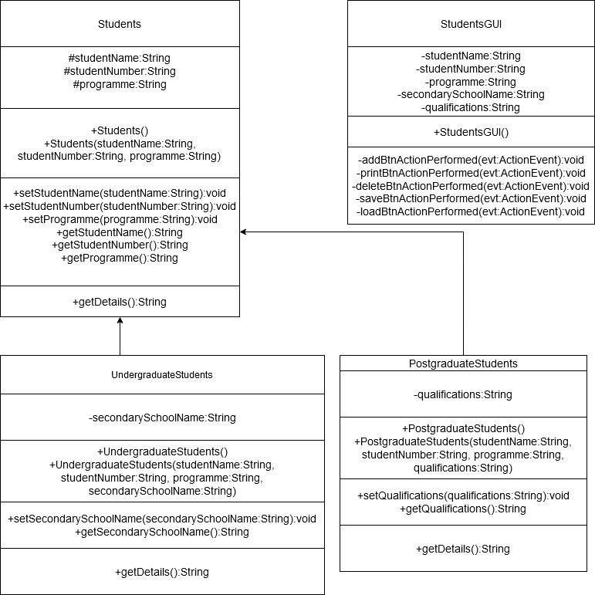

**GUI Mockup**

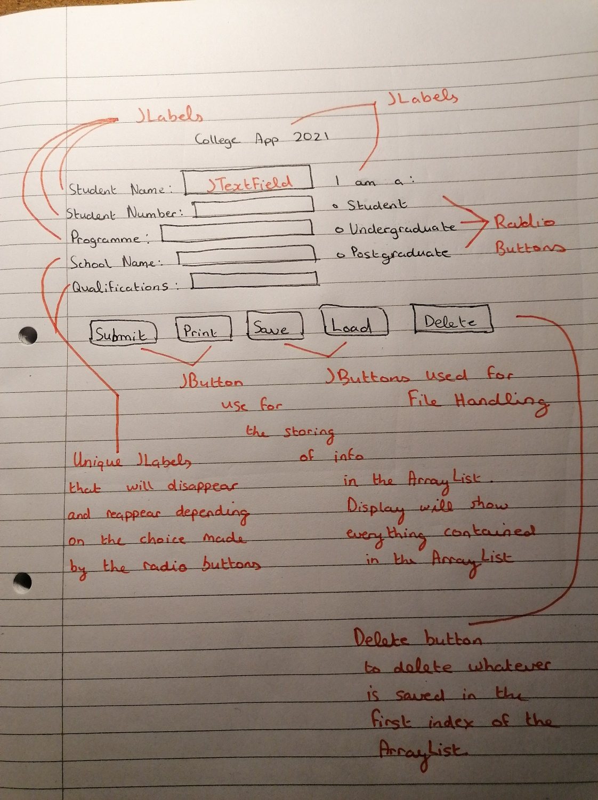

**Test Case**

|  |  |  |  |  |  |
| --- | --- | --- | --- | --- | --- |
| **TestID** | **Description** | **Test Data** | **Expectations** | **Reality** | **Pass/**  **Fail** |
| 1 | To test if my add function works | Students s = new Students();  s.setStudentName(studentNameTf.getText);  s.setStudentNumber(studentNumberTf.getText);  s.setProgramme(programmeTf.getText()); | Everything that was set in the add button function to be added to my ArrayList | Does everything that was expected to do. | Pass |
| 2 | To test if the print function works | for(Students s : studentsArr){  JOptionPane.showMessageDialog(null,s.getDetails());  } | To print everything that was saved onto the ArrayList | Everything prints out successfully back to the user | Pass |
| 3 | To test if the save function works | File f;  FileOutputStream fStream;  ObjectOutputStream oStream; | To create a file and have the content of the ArrayList successfully saved onto the file | The file has been create successfully without any errors | Pass |
| 4 | To test if the load function works | File f;  FileInputStream fStream;  ObjectInputStream oStreaml | To load everything that was saved onto the file | Everything loads correctly when the load button is called | Pass |
| 5 | To test if the delete function works | studentsArr.remove(0);    JOptionPane.showMessageDialog(null,"The first content of the Array has been successfully deleted!"); | When the delete button is pressed the first index of the arraylist will be deleted | The first index of the array list gets successfully deleted | Pass |